Momentum W.S.

- A moving car has momentum. If it moves twice as fast, its momentum is as much.

- Two cars, one twice as heavv as the other, move down a hill at the same speed. Compared to the lighter car, the momentum of the heavier car is as much.

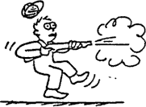
- The recoil momentum of a gun that kicks is the momentum of the bullet it fires.

more than | less than | the same as

- If a man firmly holds a gun when fired, then the momentum of the bullet is equal to the recoil momentum of the .

gun alone | gun-man system | man alone

Refer to the following information for the next five questions.

5. Suppose you are traveling in a bus at highway speed on a nice summer day and the momentum of an unlucky bug is suddenly changed as it splatters onto the front window.
  - Compared to the force that acts on the bug, how much force acts on the bus?

more | the same | less

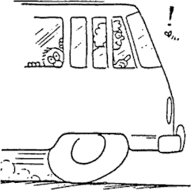
  - The time of impact is the same for both the bug and the bus. Compared to the impulse on the bug, this means the impulse on the bus is .

more | the same | less

  - Although the momentum of the bus is very large compared to the momentum of the bug, the change in momentum of the bus, compared to the change of momentum of the bug is .

more | the same | less

  - Which undergoes the greater acceleration?

the bus | both are equal | the bug

  - Which therefore, suffers the greater damage?

the  bus | both are equal | the bug of course!

Momentum conservation for colliding balls, freight cars, and fish are worked out in the text book. Here we consider more collisions In the tables below, fill in the numerical values for total momentum before, velocity after the collision, and total momentum after the collision for each two body system.

Bumper cars are fun! Refer to the following information for the next three questions.

- Assume each car with its occupant has a mass of 200 kg.
BEFORE | momentum (kg m/sec) |  | AFTER | velocity (m/sec) | momentum (kg m/sec)
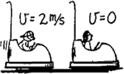 | A |  | 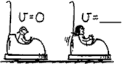 | B | C

A

B

C

Refer to the following information for the next three questions.

- Assume each car with its occupant has a mass of 200 kg.
BEFORE | momentum (kg m/sec) | AFTER | velocity (m/sec) | momentum (kg m/sec)
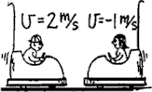 | D | 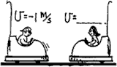 | E | F

D

E

F

Refer to the following information for the next three questions.

- Assume each car with its occupant has a mass of 200 kg.
BEFORE | momentum (kg m/sec) | AFTER | velocity (m/sec) | momentum (kg m/sec)
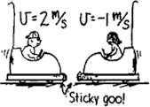 | G | 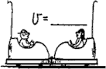 | H | I

G

H

I

Granny and Ambrose Refer to the following information for the next two questions.

- Granny whizzes around the rink and is suddenly confronted with Benny at rest directly in her path. Rather the knock him over, she picks him up and continues in motion without “braking”.

Granny’s mass = 60 kg Granny’s initial speed = 4 m/s Benny’s mass = 30 kg Benny’s initial speed = 0 m/s

BEFORE | momentum (kg m/sec) |  | AFTER | velocity (m/sec)
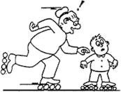 | J |  | 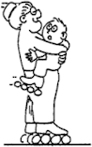 | K
J

K

- Arnold Strongman and Suzie Small pull on opposite ends of a rope in a tug of war. The greatest
force exerted on the rope is by .

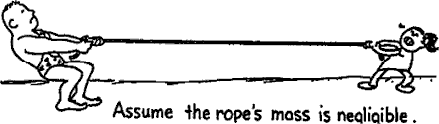

- Arnold
- Suzie
- ... both the same

Refer to the following information for the next 24 questions.

Vocabulary. Match the correct term to each statement by placing its letter in the blank.

- dynamic equilibrium  - friction  - unbalanced, outside force  - freebody diagram  - 3rd Law  - kinematics  - air resistance  - normal  - terminal velocity  - vector  - resultant  - dynamics | - static equilibrium  - inertia  - mass  - sliding  - accelerated  - scalar  - weight  - force  - same  - newton  - direction
11. A change in an object's state of motion is caused by a(n)
.

- In the metric system, forces are measured in a unit called .

- is the study of the relationships that exist between forces and the motion of objects.

- is the property of an object which causes it to resist all changes in its state of motion.

- A is an interaction between two objects.

- An object is when an unbalanced force acts on it.

- Acceleration of an object varies directly with the applied force and inversely with the of the object.

- is the measurement of the gravitational force action on an object.

- Static friction is greater than friction.

- A is the sum of two or more vectors.

- An object moving at a constant velocity is in a state of .

- An object at rest is in a state of .

- The force of friction depends on the types of surfaces in contact and the net force pressing the two surfaces together.

- The amount of a projectile encounters depends on the projectile's velocity and surface area.

- Mass and speed are examples of quantities.

- Acceleration and force are examples of quantities.

- is a force that opposes motion.

- Although forces have the same magnitude and act in opposite directions, they cannot cancel each other since they act on different objects.

- When the air resistance a projectile encounters as it is falling equals its weight, it reaches .

- A graphical technique used to illustrate all of the forces acting on an object.

- Objects are accelerating if there is either a change in their rate of motion, that is, their speed, or if there is a change in their of motion.

- is the study of motion without regard to forces.

- 2nd law forces are forces which act on the object.

- In freefall, the only force acting on an object is the pull of gravity. This force is measured quantitatively by the object's .
- Two people of equal mass, 6 meters apart, attempt a tug of war on frictionless ice. If they pull on opposite ends of the rope with equal forces, each slides 3 meters to a point midway between them.

Suppose instead that only one person pulls and the other fastens the rope around his or her waist. How for does each person slide? (Neglect any effects of the rope's mass.)

- Your weight is the result of the gravitational force of the earth on your body. Describe the corresponding reaction force.

- If you step off a ledge, you accelerate noticeably toward the earth because of the gravitational interaction between you and the earth. Does the earth accelerate towards you as well? Explain

- When a high jumper leaves the ground, what is the source of the upward force that accelerates her?

- What force acts on her once her feet are no longer in contact with the ground?

Refer to the following information for the next two questions.

- A bicycle and a massive truck have a head-on collision.

  - Upon which vehicle is the impact force greater?

bicycle | truck

  - Which vehicle undergoes the greater change in its motion?
bicycle | truck

Refer to the following information for the next two questions.

41. A speeding bus makes contact with a lovebug that splatters onto its windshield. Because of the sudden impact force, the unfortunate bug undergoes a sudden loss of speed.

a) Is the corresponding impact force that the bug exerts against the windshield of the bus greater, the same, or less than that which it experienced?

greater than | the same | less than

b) Is the resulting change in speed of the bus greater than, the same, or less than that of the bug?
greater than the same less than
Refer to the following information for the next three questions.

42. Suppose you exert 200-N of force on your refrigerator and push it across the kitchen floor at a constant velocity.
a. How large is the friction force that acts between the refrigerator and the floor?

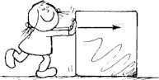
b. Does the friction force cancel your applied 200 N-force, thus making acceleration impossible?

yes | no

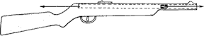
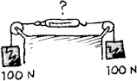
c. Could the friction force be defined as the reaction force to your applied force?
yes no
Refer to the following information for the next question.
43. Since the force that acts on a bullet when a gun is fired is equal and opposite to the force that acts on the gun, does this imply a zero net force and therefore the impossibility of an accelerating bullet? Explain.

Refer to the following information for the next three questions.

44. Consider the two forces acting on the person who stands still, namely the downward pull of gravity,
mg, and the upward support of the floor, .

- Are these forces equal and opposite?

yes | no

- Do they form an action-reaction pair? That is, are they 3rd Law forces?

yes | no

c. Do they cancel each other making acceleration equal to zero? That is, are they 2nd Law forces?
yes no
Refer to the following information for the next three questions.

45. Two 100 N weights are attached to a spring scale as shown.
a. Does the spring scale read 0 N, 100 N, or 200 N?

b. Would the spring scale reading change if the left pulley was removed and the left string attached to a stationary vertical pole?

- While the left string is attached to a stationary vertical pole, the left 100 N weight is suspended underneath the original right-hand 100 N weight.
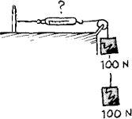

  - Does the spring scale read 0 N, 100 N, or 200 N?

Refer to the following information for the next three questions.

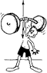
- An athlete holds a barbell stationary overhead.

  - How does the force he must exert compare to the weight of the barbell?

less than | the same | greater than

  - When the barbell was being accelerated upward, how did the athlete's applied force compare to the weight of the barbell?

less than | equal to | greater than

  - When the barbell is being accelerated downward, how does the athlete's applied force compare to the weight of the barbell?

less than | the same | greater than

Refer to the following information for the next two questions.

48. Suppose two carts, one twice as massive as the other, fly apart when the compressed spring that joins them is released.

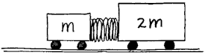
- How does the force exerted by the spring on the 1m-cart compare to the force exerted by the spring on the 2m-cart?

less than | equal to | greater than

- How fast does the 2m-cart roll compared to the smaller 1m-cart?

Refer to the following information for the next four questions.

- Consider the following 100-N hanging weight. The tension in the string could be called F_{sm}, that is, the force of the string on the mass. The mass’ weight could be called F_{em}, that is, the force of the earth on the mass.
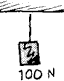

  - Are these two forces, F_{SM} and F_{EM}, 2nd Law forces or 3rd Law forces?

2nd Law forces | 3rd Law forces

  - Can these forces cancel each other? Why or why not?

  - What is the reaction force for F_{SM}?

  - The magnitudes of the forces F_{SM} and F_{MS} are equal and act in opposite directions. Can they cancel each other?

yes | no

- In both cases an applied force of 100 N accelerates the 100-N block.
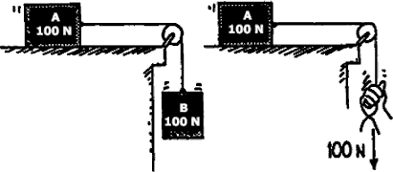

In which case is the acceleration greater?

- An ice sail-craft is stalled on a frozen lake on a windless day. A large fan blows air into the sail. If all the wind produced by the fan strikes and bounces backward from the sail, the craft will move

- to the left (backward)
- to the right (forward)
- not at all
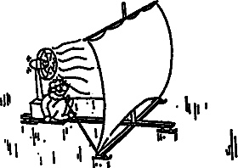

- As she falls faster and faster through the air, her acceleration .
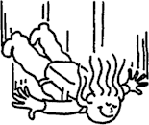

- increases
- decreases
- remains the same
- For every force there exists an equal and opposite force. Consider action and reaction forces in the case of a rock falling under the influence of gravity. If action is considered to be that of the Earth pulling down on the rock, can you clearly identify the reaction force?
